Sprint 1 Plan

CryptoTracker

CryptoTracker Developers

January 19th, 2018

**Sprint 1 Goal:**

Familiarize ourselves with the technologies and start tracking the prices of Bitcoin.

**Task Listing/User Story:**

*User Story 1:* As a user, I want to track the price of Bitcoin (3)

* Find and learn APIs from cryptocurrency exchanges

*User Story 2*: As a developer, I want to learn pertinent technologies such as React (8)

* Read documentation on React
* Watch videos as to how it would work
* Set up an environment so we can start working

**Team Roles:**

Alex Au - Product Owner/Developer

Kianna Mark - Scrum Master/Developer

Alex Lim - Developer

William Chan - Developer

Drew Caltagirone - Developer

**Initial Task Assignments:**

Alex Au - User Story 1 and 2, focus on learning all technologies and research API options

Kianna Mark - User Story 1 and 2, focus on learning all technologies and research API options

Alex Lim - User Story 1 and 2, focus on learning all technologies and research API options

William Chan - User Story 1 and 2, focus on learning all technologies and research API options

Drew Caltagirone - User Story 1 and 2, focus on learning all technologies and research API options

**Burnup Chart:**

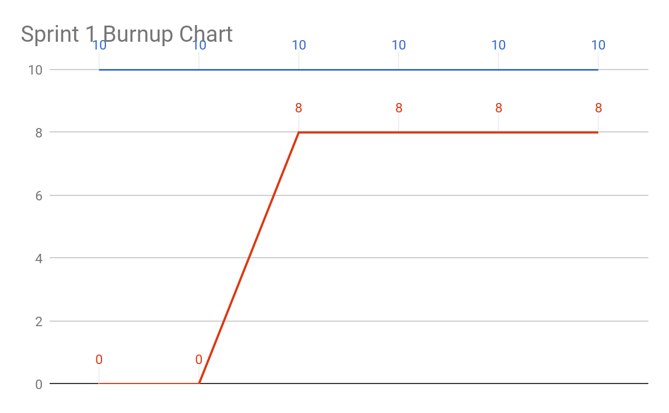

**Scrum Board:**William Chan

|  |  |  |  |
| --- | --- | --- | --- |
| **User Stories** | **Tasks Not started** | **Tasks In Progress** | **Tasks Completed** |
| *User Story 1:* As a user, I want to track the price of Bitcoin (3) |  | * Find and learn APIs from cryptocurrency exchanges |  |
| *User Story 2:* As a developer, I want to learn pertinent technologies such as React (8) |  |  | * Read documentation on React * Watch videos as to how it would work * Set up an environment so we can start working |
|  |  |  |  |

**Scrum Times:**

Monday 9:05-9:20AM

Wednesday 9:05-9:20AM

Friday 9:05-9:20AM